**JOBSHEET 4**

**Pseudocode & Flowchart**



**Name**

Sherly Lutfi Azkiah Sulistyawati

**NIM**

2341720241

**Class**

1I

**Department**

Information Technology

**Study Program**

D4 Informatics Engineering

Labs Activity

**Question! (Experiment 1)**

1. From experiment 1 above, modify the pseudocode by creating a new variable phi to store 3.14. And in the circumference and area calculation, replace 3.14 by using phi (use phi instead of 3.14 in the calculation).
2. Create the flowchart from the modified pseudocode at question 1!
3. Implements the modified pseudocode/flowchart into a program (source code)!

**Answer!**

**Algorithm:** Circle24

(input radius and calculate the circumference and area of the circle)

**Declaration:**

r : int

phi=3.14, circumference, area : double

**Description:**

1. Print “Input radius”
2. Read r
3. Area = phi*r*r
4. Circumference = 2*phi*r
5. Print area
6. Print circumference

2.

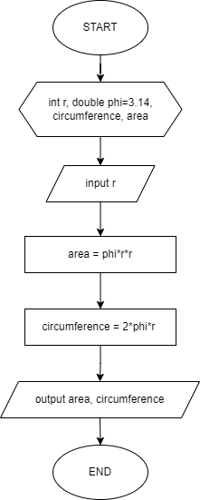

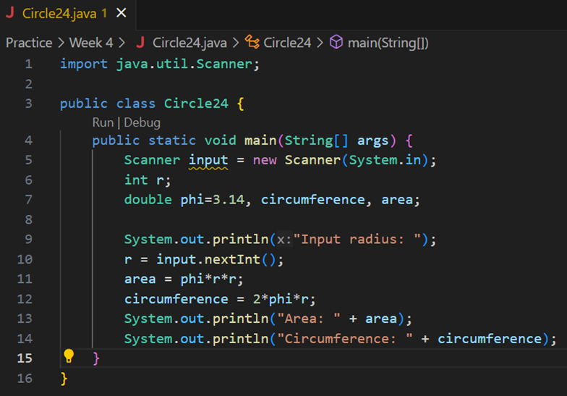

**Question! (Experiment 2)**

1. Create a pseudocode based on the above flowchart and modify it by getting the salary and salaryDeduction from the user input!
2. Implement the modified pseudocode in the above question, into a java program!

**Answer!**

**Algorithm:** Salary24

(input attendance number, absence number, salary, salary deduction and calculate the total salary)

**Declaration:**

numAttendance, numAbsence, totalSalary, salary, salaryDeduction : int

**Description:**

1. Print “Input attendance number”
2. Read numAttendance
3. Print “Input absence number”
4. Read numAbsence
5. Print “Input salary”
6. Read salary
7. Print “Input salary deduction”
8. Read salaryDeduction
9. Total salary=(numAttendance*salary)-(numAbsence*salaryDeduction)
10. Print “Total salary“
11. Print totalSalary

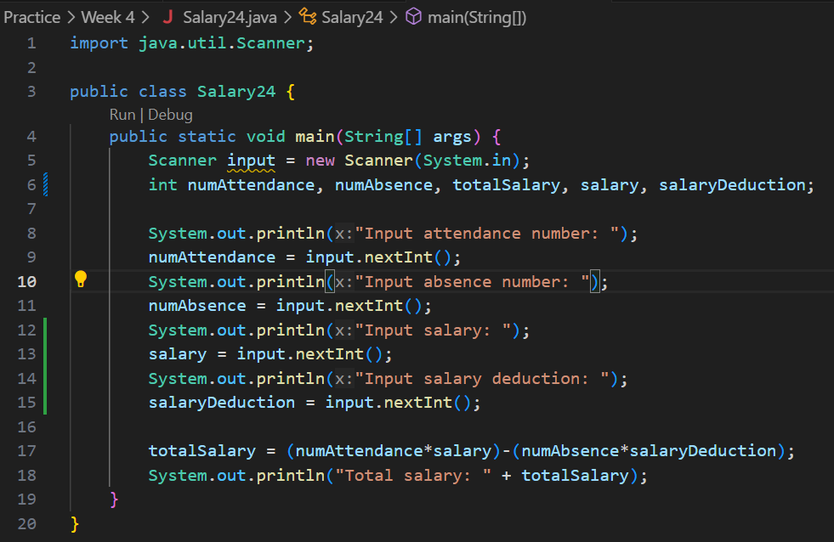

**Question! (Experiment 3)**

1. Modify the pseudocode and flowchart above by adding user input for **bookBrand** and **pageCount**, then change the **discount** to get the user input as well!
2. Implement the changes in a program!

**Answer!**

**Algorithm:** NotebooksPurchasePriceStudent24

(input book brand, page count, price, quantity and calculate the discount and total price)

**Declaration:**

bookBrand : String

pageCount, price, quantity: int

discount=0.15, totalPrice, purchasePrice, totalDiscount : double

**Description:**

1. print “Input book brand”
2. read bookBrand
3. print “Input page count”
4. read pageCount
5. print “Input price”
6. read price
7. print “Input quantity”
8. read quantity
9. totalPrice = price * quantity
10. totalDiscount=totalPrice*discount
11. purchasePrice= totalPrice – totalDiscount
12. print “Book brand”
13. print bookBrand
14. print “Page count”
15. print pageCount
16. print “The total discount”
17. print totalDiscount
18. print "The Purchase Price”
19. print purchasePrice

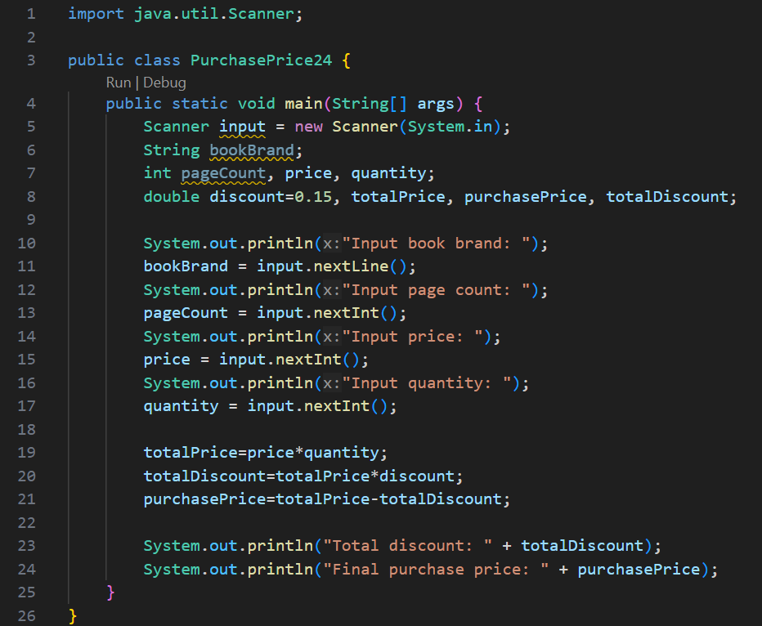

**Assignment**

1. Create pseudocode based on your group project. The pseudocode that you create can be identified from the processes (it could be input, output and arithmetic process etc.)!
2. From the answer to question 1, please create the flowchart for each pseudocode that is already created! Implements the modified pseudocode/flowchart into a program (source code)!
3. Implement the pseudocode/flowchart into a program. Please make a note that the program will only include input, output, variable declarations, arithmetic operation (and any other operator). Since we haven’t reached condition selection, looping, method, array, then you do not have to use it right now.

**Answer!**

**Algorithm:** EmployeePayrollSystem

(input name, category, work hours, salary per hour, overtime and calculate the basic salary, bonus, allowance, and salary)

**Declaration:**

name : String

category, salaryPerHour, workHours, basicSalary, overtime, tip = 20000, bonus, salary, allowance: int

**Description:**

1. print " Employee Payroll "
2. print "============================================"
3. print “Name”
4. read name
5. print “Category”
6. read category
7. print “Work Hours”
8. read workHours
9. print “Salary Per Hour”
10. read salaryPerHour
11. print “Overtime”
12. read overtime
13. basicSalary = workHours*salaryPerHour
14. bonus = overtime*tip
15. salary = basicSalary + bonus
16. print "============================================"
17. print “Basic Salary”
18. print basicSalary
19. print “Bonus”
20. print bonus
21. print “Allowance”
22. print allowance
23. print “Salary”
24. print salary
25. From the answer to question 1, please create the flowchart for each pseudocode that is already created! Implements the modified pseudocode/flowchart into a program (source code)!
26. Implement the pseudocode/flowchart into a program. Please make a note that the program will only include input, output, variable declarations, arithmetic operation (and any other operator). Since we haven’t reached condition selection, looping, method, array, then you do not have to use it right now.